- Deploy an application using a Deployment with 3 replicas and a rolling update strategy.
File name: deployment.yaml
apiVersion: apps/v1
kind: Deployment
metadata:
name: nginx-deployment
labels:
app: nginx
spec:
replicas: 3 # Number of replicas
selector:
matchLabels:
app: nginx
strategy:
type: RollingUpdate
rollingUpdate:
maxUnavailable: 1 # At most 1 pod unavailable during update
maxSurge: 1 # At most 1 extra pod created during update
template:
metadata:
labels:
app: nginx
spec:
containers:
- name: nginx
image: nginx:1.21 # Initial image version
ports:
- containerPort: 80
2. Apply the Deployment
kubectl apply -f deployment.yaml
3. Verify the Deployment
Check Deployment status:
kubectl get deployments
Check Pods created:
kubectl get pods -o wide
Check details of rollout:
kubectl rollout status deployment/nginx-deployment
4. Test Rolling Update
Update the image version in your YAML (for example, from nginx:1.21 → nginx:1.25):
image: nginx:1.25
Apply the change:
kubectl apply -f deployment.yaml
Monitor the rolling update process:
kubectl rollout status deployment/nginx-deployment
If you need to undo the update:
kubectl rollout undo deployment/nginx-deployment
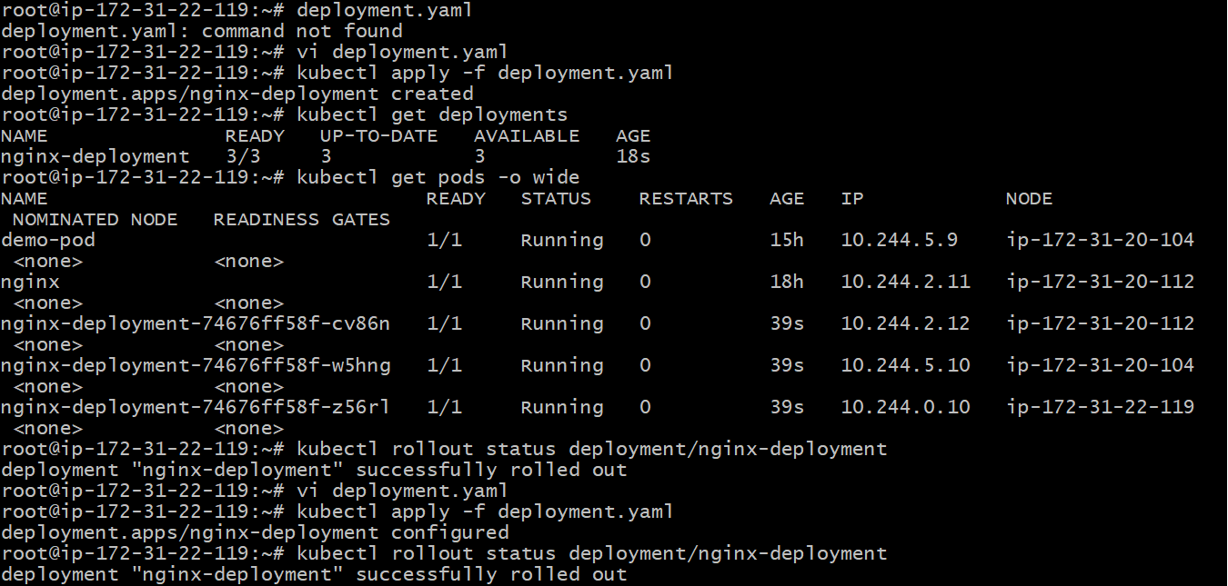
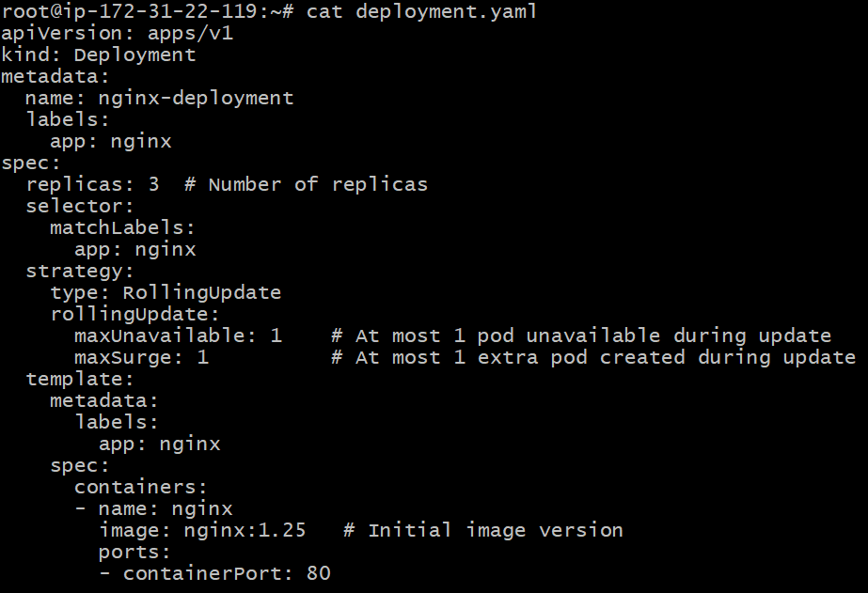
- Configure a Deployment with a Recreate strategy and observe the downtime.
Step 1: Create a Deployment with “Recreate” Strategy
File name: recreate-deployment.yaml
apiVersion: apps/v1
kind: Deployment
metadata:
name: nginx-recreate
labels:
app: nginx-recreate
spec:
replicas: 3
selector:
matchLabels:
app: nginx-recreate
strategy:
type: Recreate # 👈 This means all old Pods are killed before new ones start
template:
metadata:
labels:
app: nginx-recreate
spec:
containers:
- name: nginx
image: nginx:1.21
ports:
- containerPort: 80

Step 2: Apply the Deployment
kubectl apply -f recreate-deployment.yaml
Verify:
kubectl get deployments
kubectl get pods -o wide
Step 3: Update the Deployment to Trigger “Recreate”
Edit the YAML and change the image version (for example: nginx:1.21 → nginx:1.25):
image: nginx:1.25
Then apply the update:
kubectl apply -f recreate-deployment.yaml
Step 4: Observe the Downtime
Now, watch the rollout process:
kubectl get pods -w
You will notice:
All existing Pods (nginx:1.21) terminate first.
Then, new Pods (nginx:1.25) are created after the old ones are gone.
During this gap, no Pods are serving traffic, leading to downtime.
Step 5: Verify the Strategy
To confirm the strategy type:
kubectl describe deployment nginx-recreate | grep Strategy
Output should look like:
StrategyType: Recreate
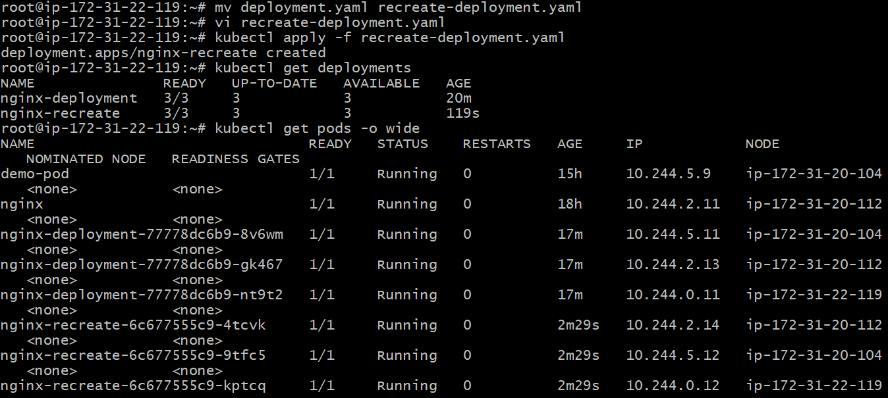
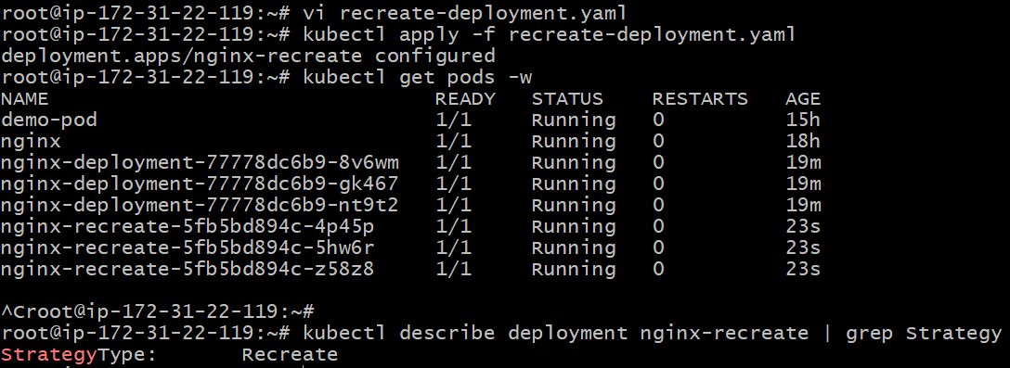
- Update an existing Deployment and perform a rollback to the previous version.
File name: rollback-deployment.yaml
apiVersion: apps/v1
kind: Deployment
metadata:
name: nginx-rollback
labels:
app: nginx-rollback
spec:
replicas: 3
selector:
matchLabels:
app: nginx-rollback
template:
metadata:
labels:
app: nginx-rollback
spec:
containers:
- name: nginx
image: nginx:1.21 # Initial version
ports:
- containerPort: 80
Step 2: Deploy It
kubectl apply -f rollback-deployment.yaml
Verify:
kubectl get deployments
kubectl get pods
Step 3: Update the Deployment (Trigger a New Revision)
Edit the file and update the image tag (for example, nginx:1.21 → nginx:1.25):
image: nginx:1.25
Apply the update:
kubectl apply -f rollback-deployment.yaml
Monitor the rollout:
kubectl rollout status deployment/nginx-rollback
Step 4: Check Deployment History
To view rollout revisions:
kubectl rollout history deployment/nginx-rollback
Example output:
deployment.apps/nginx-rollback
REVISION CHANGE-CAUSE
1 <none>
2 <none>
You can also describe a specific revision:
kubectl rollout history deployment/nginx-rollback --revision=1
Step 5: Rollback to Previous Version
To rollback to the previous working version:
kubectl rollout undo deployment/nginx-rollback
If you want to rollback to a specific revision:
kubectl rollout undo deployment/nginx-rollback --to-revision=1
Step 6: Verify Rollback
Check Deployment image:
kubectl describe deployment nginx-rollback | grep Image
Expected output:
Image: nginx:1.21
Check rollout status again:
kubectl rollout status deployment/nginx-rollback

Updated an existing yaml file
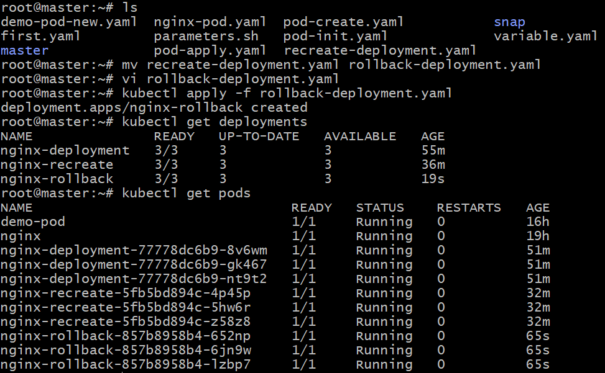

Modified version from 1.21 to 1.25.
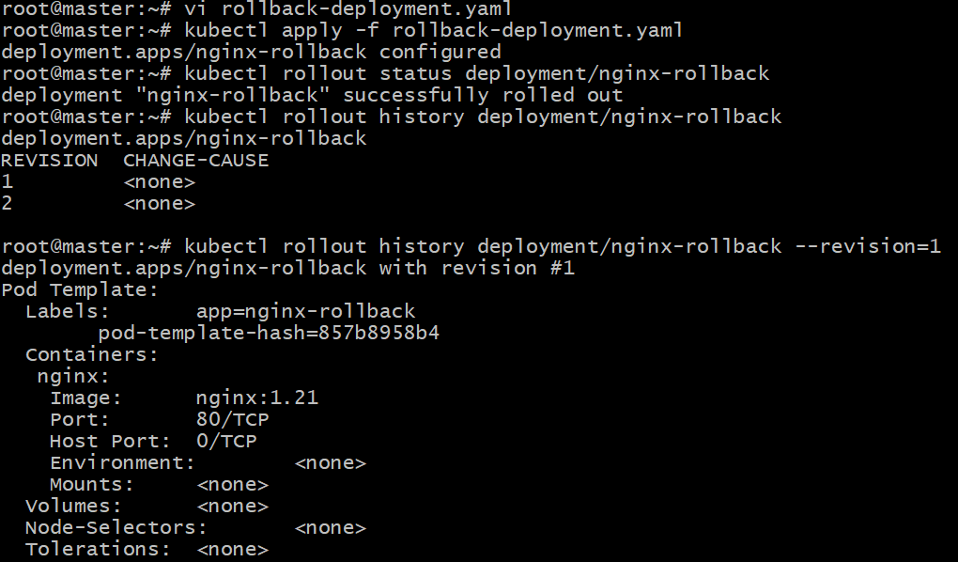
Undo the previous deployment to 1.21 version
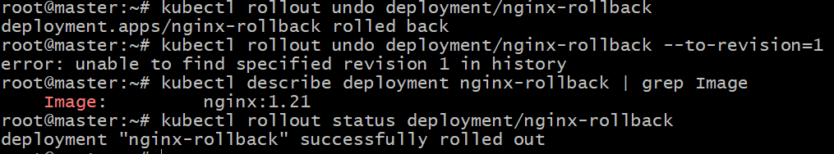
- Modify a Deployment to add resource requests and limits for CPU and memory.
Step 1: Start with an Existing Deployment
Let’s assume you already have a Deployment named nginx-deployment.
If not, create a base Deployment file called resource-deployment.yaml:
apiVersion: apps/v1
kind: Deployment
metadata:
name: nginx-resources
labels:
app: nginx-resources
spec:
replicas: 3
selector:
matchLabels:
app: nginx-resources
template:
metadata:
labels:
app: nginx-resources
spec:
containers:
- name: nginx
image: nginx:1.21
ports:
- containerPort: 80

Step 2: Add Resource Requests and Limits
Now modify the container specification to include resources:
apiVersion: apps/v1
kind: Deployment
metadata:
name: nginx-resources
labels:
app: nginx-resources
spec:
replicas: 3
selector:
matchLabels:
app: nginx-resources
template:
metadata:
labels:
app: nginx-resources
spec:
containers:
- name: nginx
image: nginx:1.21
ports:
- containerPort: 80
resources:
requests:
cpu: "100m" # Minimum CPU (0.1 core)
memory: "128Mi" # Minimum memory (128 MB)
limits:
cpu: "250m" # Maximum CPU (0.25 core)
memory: "256Mi" # Maximum memory (256 MB)
Step 3: Apply the Updated Deployment
kubectl apply -f resource-deployment.yaml
Step 4: Verify Resource Requests and Limits
Run:
kubectl describe pod -l app=nginx-resources | grep -A5 "Containers:"
You should see something like:
Containers:
nginx:
Limits:
cpu: 250m
memory: 256Mi
Requests:
cpu: 100m
memory: 128Mi
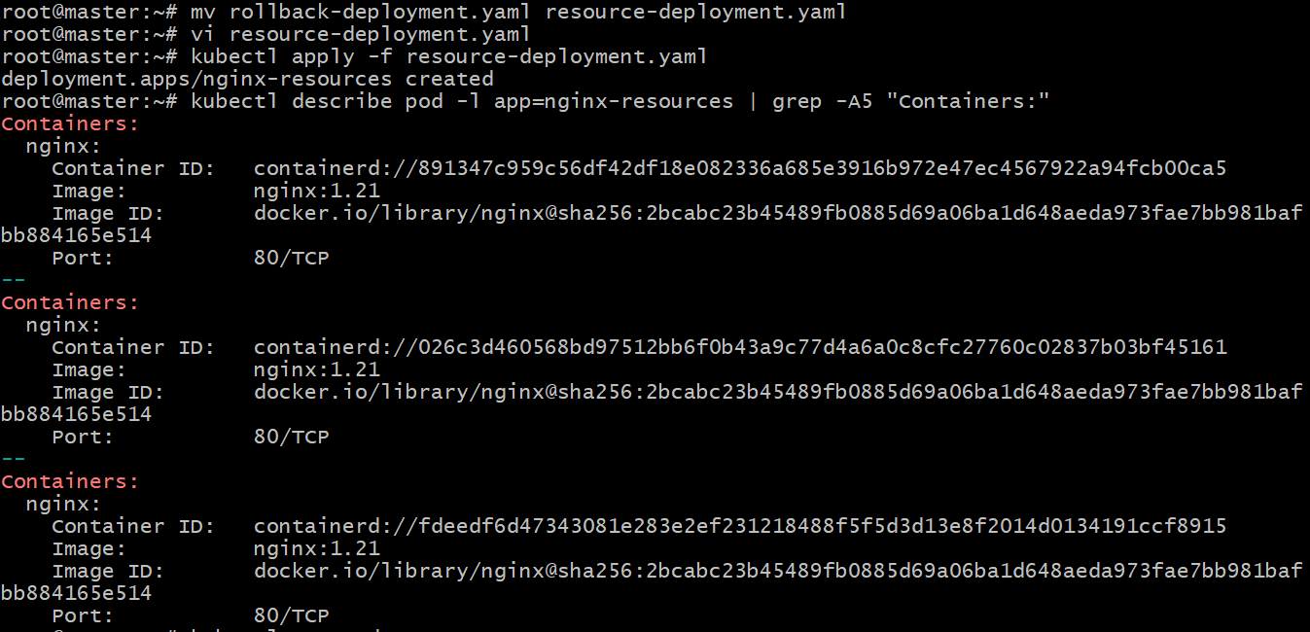
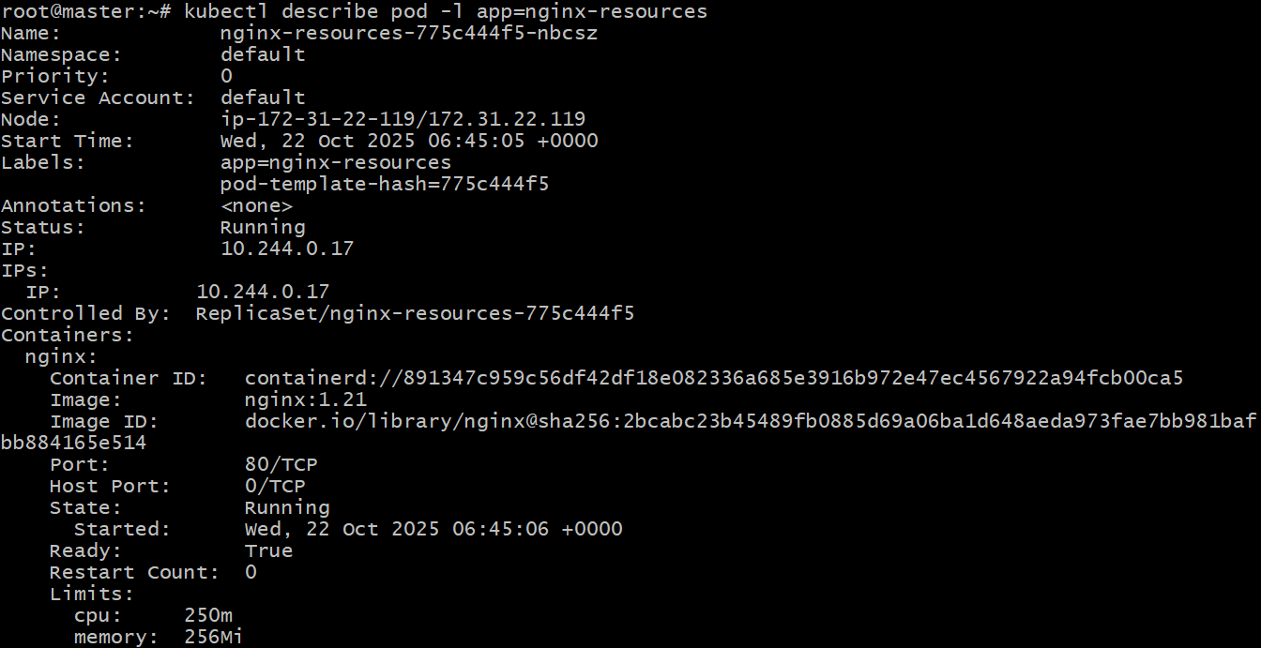
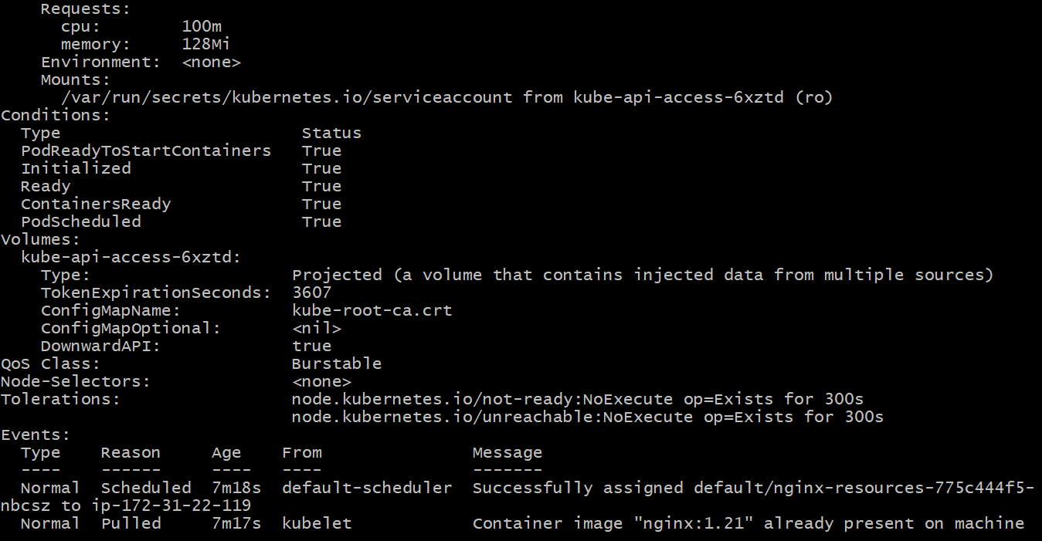

Step 5: Understand What These Values Mean
Resource Type | Purpose | Example Value | Description
Requests | Minimum resources guaranteed to the container | cpu: 100m, memory: 128Mi | Scheduler ensures node has at least this much available
Limits | Maximum resources the container can use | cpu: 250m, memory: 256Mi | Container can’t exceed this; throttling or OOMKill if exceeded

- Create a Deployment with MaxSurge and MaxUnavailable configurations.
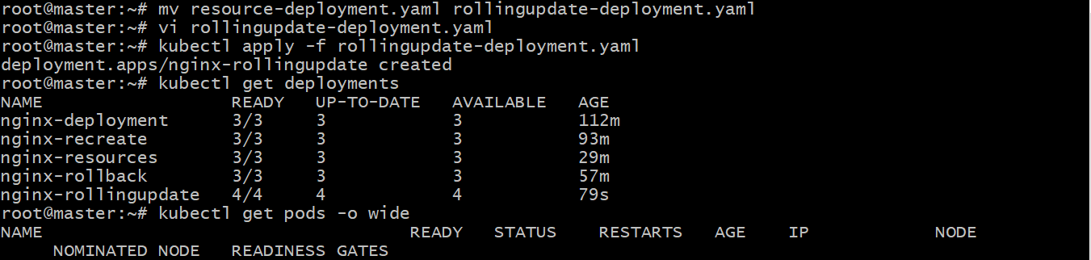
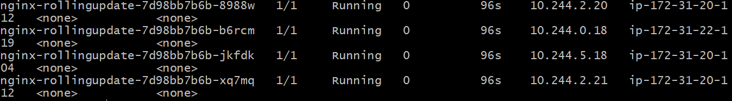
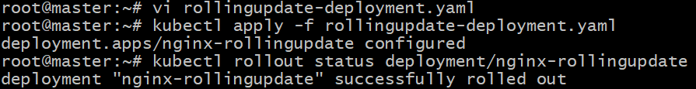
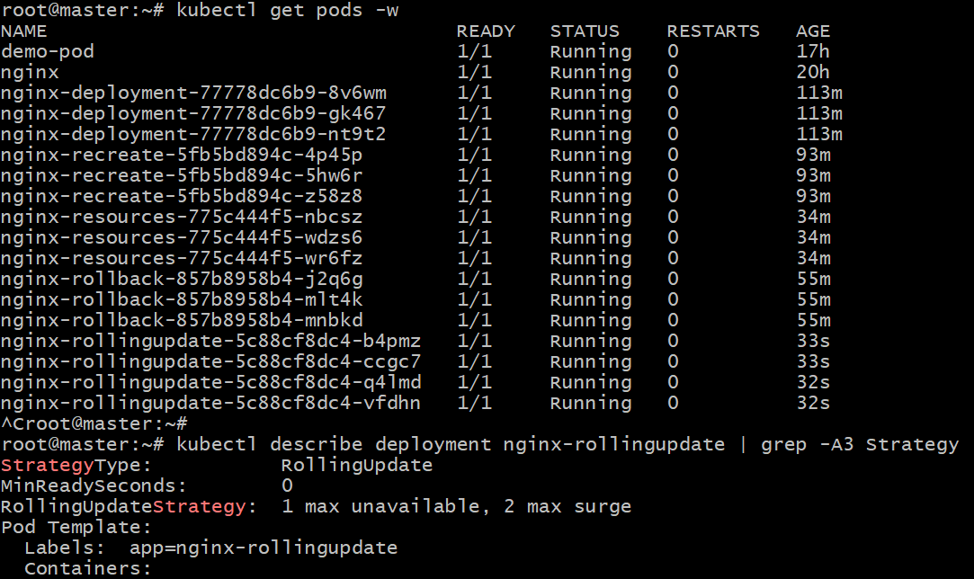
Understanding maxSurge & maxUnavailable
Field | Description | Example
maxSurge | How many extra Pods above desired replicas can be created during update | 2 means 4 desired + 2 extra = max 6 Pods temporarily
maxUnavailable | How many Pods can be unavailable during update | 1 means at least 3 Pods remain available
Default Values | If not set, both default to 25%

- Set up a Deployment with a custom revision history limit.
File name: revisionlimit-deployment.yaml
apiVersion: apps/v1
kind: Deployment
metadata:
name: nginx-revisionlimit
labels:
app: nginx-revisionlimit
spec:
replicas: 3
revisionHistoryLimit: 3 # 👈 Keeps only the last 3 revisions
selector:
matchLabels:
app: nginx-revisionlimit
strategy:
type: RollingUpdate
rollingUpdate:
maxSurge: 1
maxUnavailable: 1
template:
metadata:
labels:
app: nginx-revisionlimit
spec:
containers:
- name: nginx
image: nginx:1.21
ports:
- containerPort: 80
Step 2: Apply the Deployment
kubectl apply -f revisionlimit-deployment.yaml
Verify:
kubectl get deployments
Step 3: Perform Multiple Updates to Create Revisions
Let’s update the image multiple times to generate different revisions.
Update 1:
kubectl set image deployment/nginx-revisionlimit nginx=nginx:1.22
Update 2:
kubectl set image deployment/nginx-revisionlimit nginx=nginx:1.23
Update 3:
kubectl set image deployment/nginx-revisionlimit nginx=nginx:1.24
Update 4:
kubectl set image deployment/nginx-revisionlimit nginx=nginx:1.25
Step 4: Check Deployment Revision History
kubectl rollout history deployment/nginx-revisionlimit
Even though we made 4 updates, you’ll only see the last 3 revisions retained (because of revisionHistoryLimit: 3).
Older ReplicaSets (from older revisions) will have been deleted automatically.
Step 5: Verify Configuration
kubectl describe deployment nginx-revisionlimit | grep RevisionHistory
Output should look like:
Revision History Limit: 3
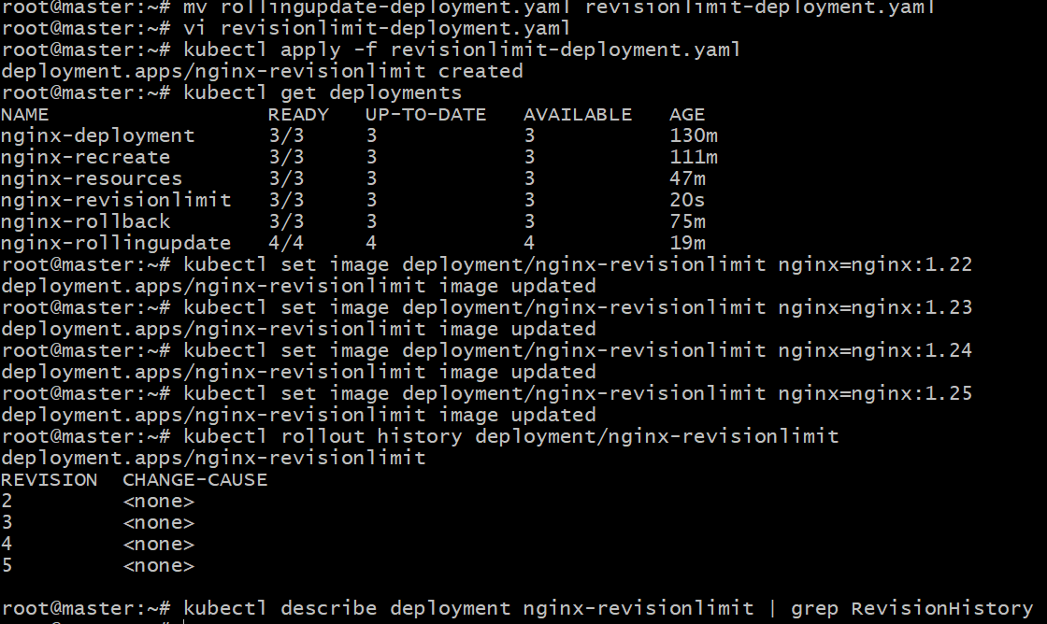
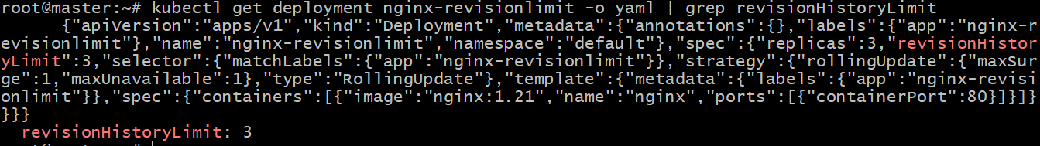
Why This Matters
Field | Purpose | Example
revisionHistoryLimit | Limits how many old ReplicaSets are kept | 3 keeps the last 3 revisions
Default | If not set, defaults to 10
Benefit | Saves cluster resources, limits rollback depth

- Pause a Deployment during an update, and then resume it.
Step 1: Create a Sample Deployment
File name: pause-deployment.yaml
apiVersion: apps/v1
kind: Deployment
metadata:
name: nginx-pause
labels:
app: nginx-pause
spec:
replicas: 3
selector:
matchLabels:
app: nginx-pause
strategy:
type: RollingUpdate
rollingUpdate:
maxUnavailable: 1
maxSurge: 1
template:
metadata:
labels:
app: nginx-pause
spec:
containers:
- name: nginx
image: nginx:1.21
ports:
- containerPort: 80
Step 2: Deploy It
kubectl apply -f pause-deployment.yaml
Check:
kubectl get deployments
kubectl get pods
Step 3: Start an Update (Change Image)
Now, update the Deployment image (for example: nginx:1.21 → nginx:1.25):
kubectl set image deployment/nginx-pause nginx=nginx:1.25
Immediately pause the rollout before it completes.
Step 4: Pause the Deployment
kubectl rollout pause deployment/nginx-pause
Verify the status:
kubectl rollout status deployment/nginx-pause
You’ll see that the rollout has been paused, meaning Kubernetes will not proceed with updating all Pods until you resume it.
Check rollout state:
kubectl get deployment nginx-pause -o yaml | grep paused
Expected output:
paused: true
Step 5: Observe the Paused State
You’ll notice:
Some Pods are old (nginx:1.21)
Some might have updated (nginx:1.25)
The update stops mid-way
Check:
kubectl get pods -l app=nginx-pause -o wide
Step 6: Resume the Deployment
Once you’re ready to continue:
kubectl rollout resume deployment/nginx-pause
Verify rollout progress:
kubectl rollout status deployment/nginx-pause
Now Kubernetes resumes updating remaining Pods.
Step 7: Verify the Final State
Check that all Pods are running the new image:
kubectl get pods -l app=nginx-pause -o wide
You should see all replicas running nginx:1.25.
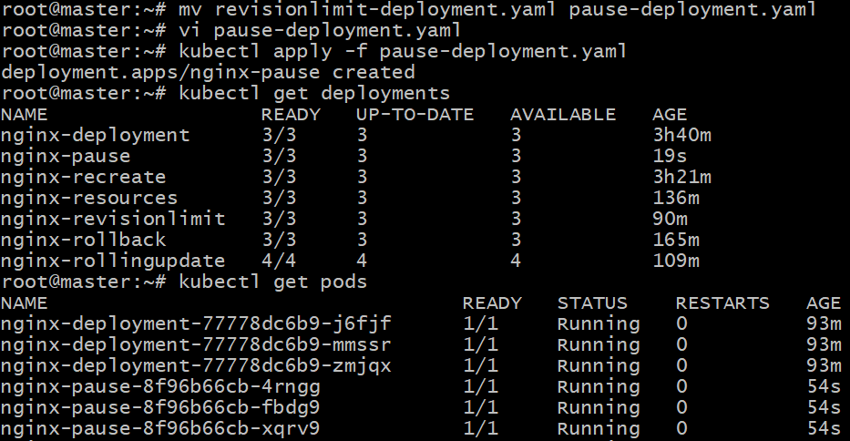
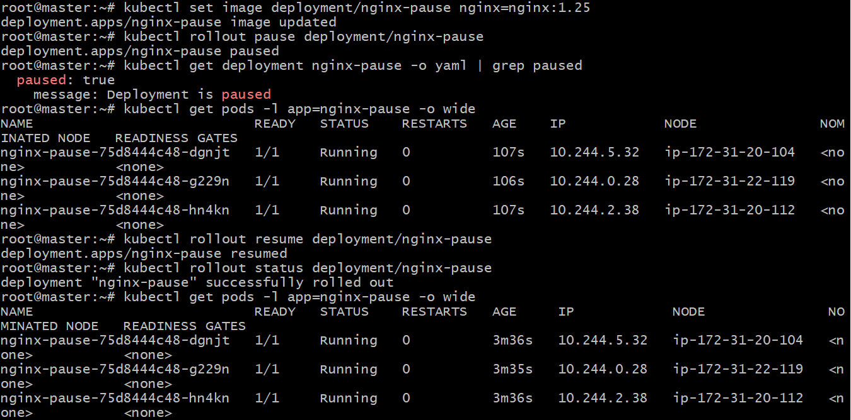

Real-World Use Case
You pause a deployment when you:
- Want to apply multiple changes (e.g., image + resource limits) before rollout.
- Need to test or inspect partial rollouts before completing them.
- Are debugging an issue in the rollout process.
- Create a pod using resource requests for memory and CPU, and observe how the scheduler assigns it to a node.
Step 1: Create a Pod with Resource Requests
File name: resource-pod.yaml
apiVersion: v1
kind: Pod
metadata:
name: nginx-resource-pod
labels:
app: nginx-resource-pod
spec:
containers:
- name: nginx
image: nginx:1.21
resources:
requests:
cpu: "200m" # Minimum 0.2 CPU cores required
memory: "256Mi" # Minimum 256 MB memory required
ports:
- containerPort: 80
Step 2: Apply the Pod
kubectl apply -f resource-pod.yaml
Step 3: Check Pod Status
Run:
kubectl get pods -o wide
You’ll see output like:
NAME READY STATUS RESTARTS AGE IP NODE
nginx-resource-pod 1/1 Running 0 10s 10.244.1.10 worker-node1
The NODE column shows which node the Kubernetes scheduler chose.
Step 4: Understand Why That Node Was Selected
You can describe the Pod to see scheduling details:
kubectl describe pod nginx-resource-pod
Look for the section:
Events:
Type Reason Age From Message
---- ------ ---- ---- -------
Normal Scheduled 10s default-scheduler Successfully assigned default/nginx-resource-pod to worker-node1
Kubernetes scheduled the Pod to a node that:
Had at least 0.2 CPU cores available
Had at least 256Mi memory available
If no node met those requirements, the Pod would stay in Pending state.
Step 5: Confirm Node Capacity vs Requests
To see each node’s available capacity and allocations:
kubectl describe nodes | grep -A5 "Allocatable"
